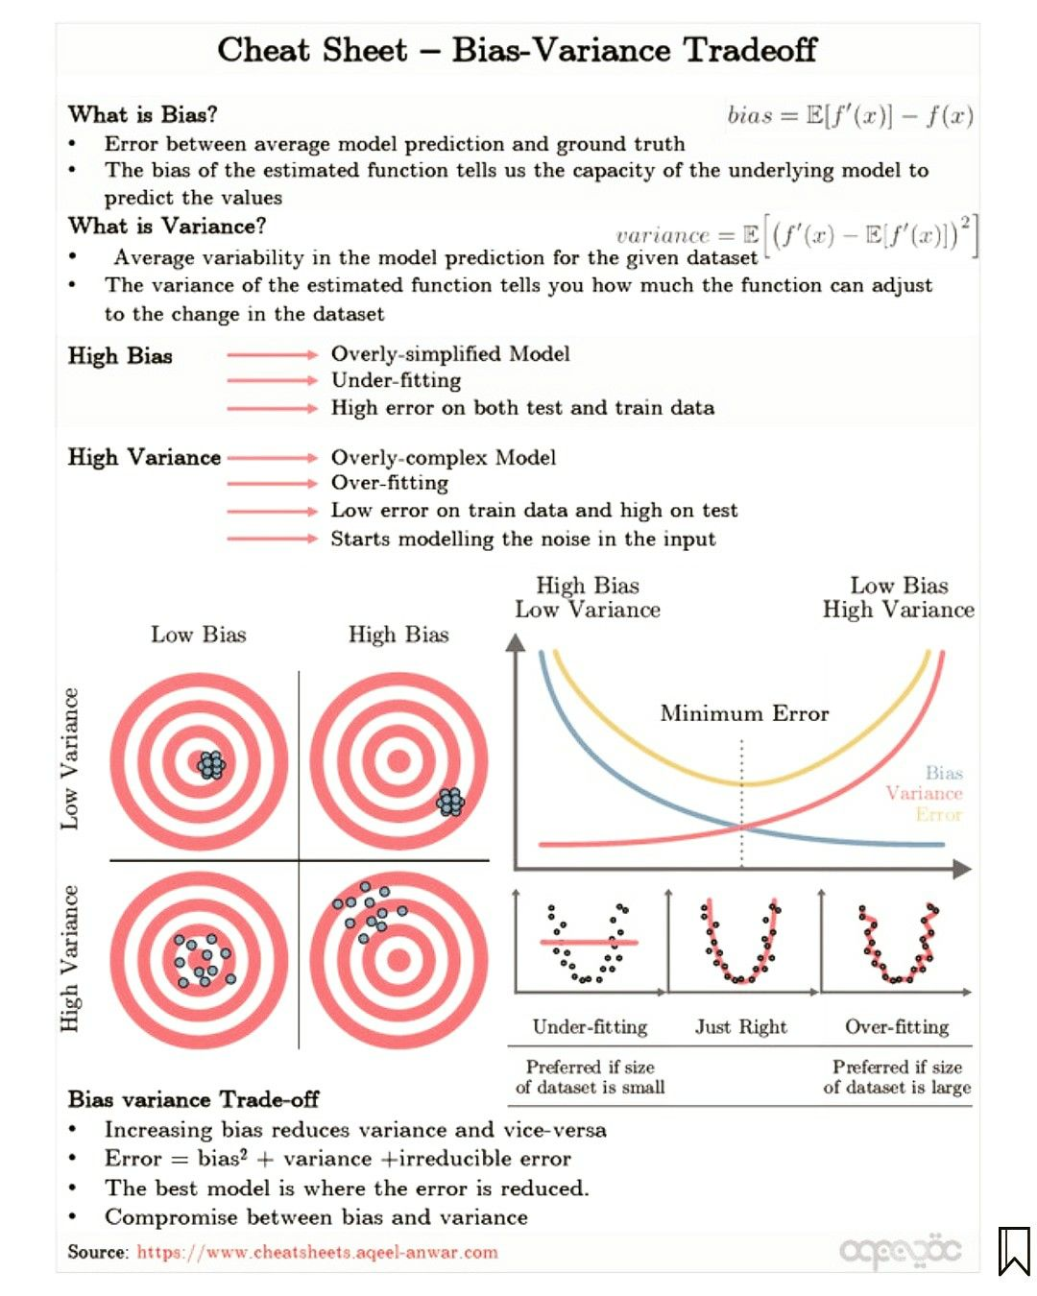

**Cross Validation:**

Like traditional Train/Test split, it is used to assess the performance of your model by randomizing the data, breaking the data up into K groups, training on K-1 groups, and testing on 1 group. You continue until each group as been tested on and end up with K number of accuracies.

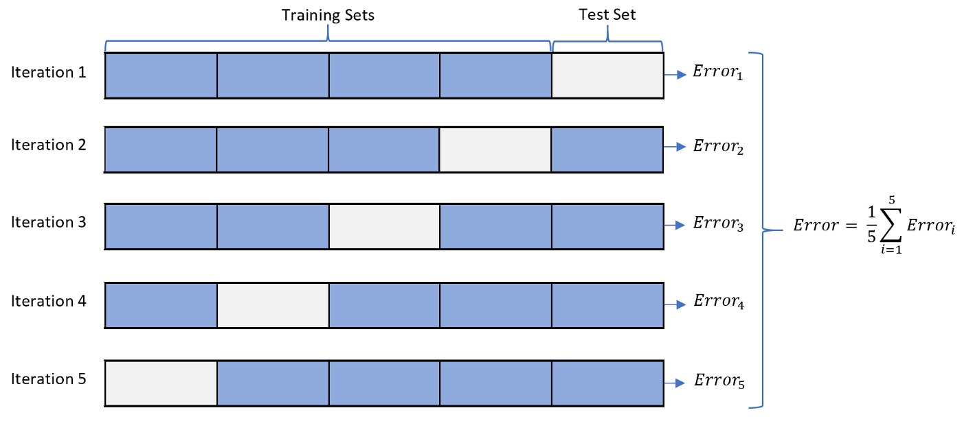This gives each point a chance to be trained on and tested on. Also reduces chances of getting a false high accuracy just by the way the data was sampled. Ensures unbiased performance

With time series, cross validation works similarly, except with a sliding window. As you continue up the X-axis, the testing dataset will always be the tail (Sliding) and the training will always be the head (Incremental). Note that you cannot randomize the data since it is time dependent

**Linear Regression:**

Statistical regression method to understand the relationship between X features and a continuous target

Must meet the following assumptions:

1. Linearity: Between all X and y

2. Homoscedasticity: The variance of residual is the same across the domain

3. Normality: All features

4. Multicollinearity: Between X features

Pros: Explainable, Interpretable, Fast ML model to train

Cons: Must meet all assumptions, sensitive to outliers, can easily underfit

**Logistic Regression:**

A probabilistic classification model that models the relationship between X features and a categorical output

Pros: Fast to train, interpretable, can use regularization to reduce overfitting

Cons: Can overfit when number of features > number of records, linear boundaries

**Decision Trees:**

* A tree-like supervised machine learning model used to predict both continuous and categorical targets
* Like a flowchart
* Top-down algorithm, so the top of the tree has the more important features, and get less important as you get down to the root notes
* At each level, there is a decision node, which uses Entropy to decide what feature to split on
* Entropy is the measure of disorder range [0,1], where 1 would imply the highest disorder (uncertainty). High disorder means that the sample is not pure or not homogenous
* Information gain (IG) measures how much “information” a feature gives us about the class. The information gain is based on the decrease in entropy after a dataset is split on an attribute. Ranges from [0,1], where 1 represents the most lift or gain from splitting a node
* Pruning is the process of cutting back the tree
* Pros: Interpretable (Explainable), can handle NULL values
* 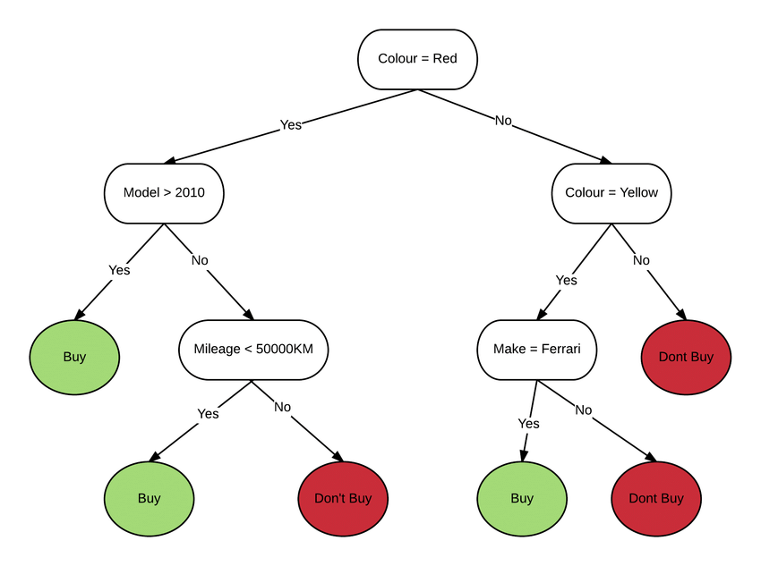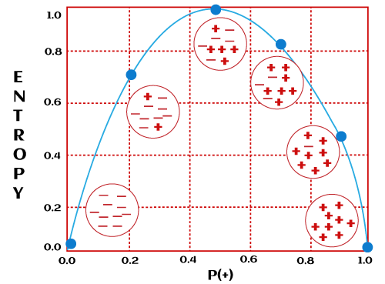Cons: Sensitive to outliers, Easy to overfit

**Random Forest:**

* A tree-based model, random forest takes decision trees to the next level
* Train a large number of decision trees (Usually 100s), in parallel, and each independent of each other
* Each tree is sampled randomly with replacement (Bootstrap Sampling)
* The output of each tree with be aggregated (ensembled to form one single prediction
* Bagging
* Pros: Less likely to overfit
* Cons: Training can be complex, not interpretable